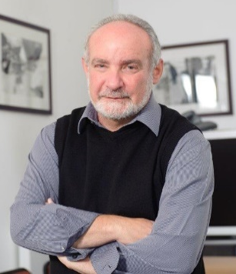
Steve Tollman
BSc (Rand), MA (Oxon), MPH (Harvard), MMED (Rand), PhD (Umeå)
Steve is founding director of the South African Medical Research Council / Wits University Rural Public Health and Health Transitions Research Unit, responsible for its world-class health and sociodemographic platform (Agincourt HDSS), and multidisciplinary research spanning the life course. He is research professor in the School of Public Health, University of the Witwatersrand, and a faculty member of the Harvard Center for Population & Development Studies. Steve studied medicine at Wits, PPE in Oxford as a Rhodes Scholar, and public health at Harvard.
Returning to South Africa in 1990, Steve with Kathy Kahn moved to rural Bushbuckridge, confronting pervasive challenges of poverty and inequality coupled with complex health transitions. Over decades, they built a globally leading research institution, bringing the best science to bear where needs are greatest. The versatile research platform – covering a ‘whole population’ cohort of some 120, 000 people living in over 30 rural villages – supports diverse observational and interventional studies, including policy evaluations, investigating critical transitions along the life course, their implications, and context-appropriate responses.
Steve was a founder and first Board Chair of INDEPTH (2002-06), an exceptional research network led from the Global South. As principal scientist, he provided strategic direction to multicentre efforts in cause-of-death, ageing, migration and health, and cardiovascular genomics. He was instrumental in gaining government investment to establish SAPRIN, a South African network of population-based research platforms building data/evidence bases to address health inequalities.

In 2024, Steve was awarded a Gold Medal by the SAMRC, and in 2023, received the Alumni Award of Merit from the Harvard TH Chan School of Public Health. He gained high recognition from INDEPTH, and the 2018 National Science and Technology Forum South32 award.
Steve serves on international thinktanks: UCL-Lancet Commission on Migration and Health (2016-18), Academy of Medical Sciences-UK Addressing the global challenge of multimorbidity (2016-18), National Academy of Sciences-USA Continuing Epidemiological Transition in sub-Saharan Africa (2010-13) and Research and Data Needs to Meet the Challenge of Aging in Africa (2004-6). He is sought after as chair of competitive review panels supporting local and global health development including SA, UK, and Ugandan Medical Research Councils, Wellcome, Global Alliance for Chronic Diseases (GACD), National Institute for Health Research-UK (NIHR), and African Research Excellence Fund (AREF).

INDEPTH: International Network for the Demographic Evaluation of Populations and Their Health

